Design of a Light switch

LAB # 09



Spring 2024
CSE-308L Digital System Design Lab

Submitted by: Ali Asghar
Registration No.: 21PWCSE2059
Class Section: C

“On my honor, as student of University of Engineering and Technology, I have neither given nor received unauthorized assistance on this academic work.”

Submitted to:
Dr. Asif Ali Khan

Date:
23rd May 2024

Department of Computer Systems Engineering
University of Engineering and Technology, Peshawar

Objectives:
This lab will enable students to:
- Build a light switch controller such that when the push button is pressed the light if “off” turns “on” and if “on” turns “off”.

Software used:
- Xilinx ISE

Block Diagram:
The top level block diagram is shown in the following figure. The second diagram is a more detailed view of the top level diagram. Synchronizer circuit is used to avoid the metastability problem which arises when synchronous digital system are fed with an asynchronous input. The level to pulse converter is there to convert level input from a push button into a pulse that is high for only one clock cycle. The switch button FSM is actually implementing the state machine for the requirement i-e when the push button is pressed the light if “off” turns “on” and if “on” turns “off”.
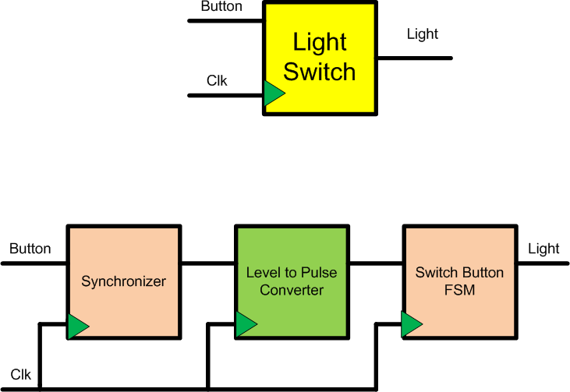
I/O connection: Connect the button input to a push button on the S3BOARD and light output to LED.

Synchronizer Circuit:

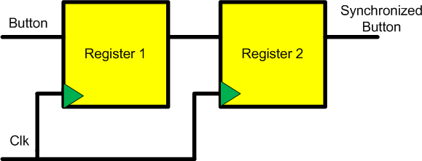
Level to Pulse FSM:

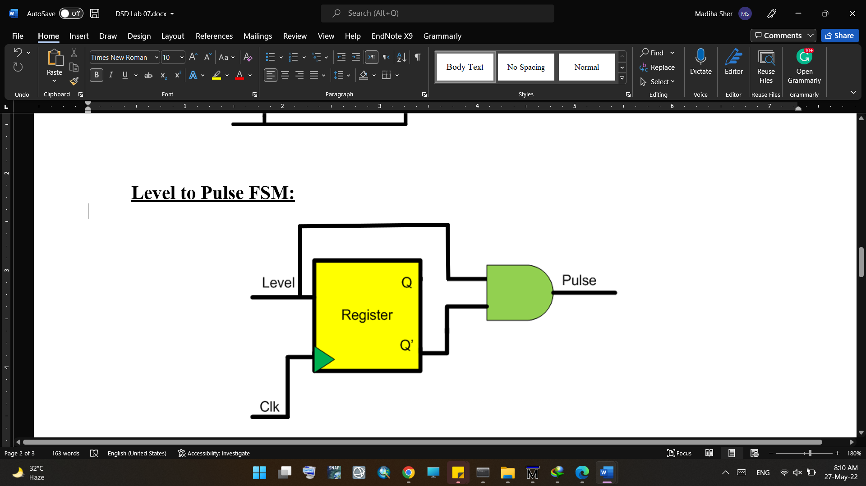

Switch Button FSM:
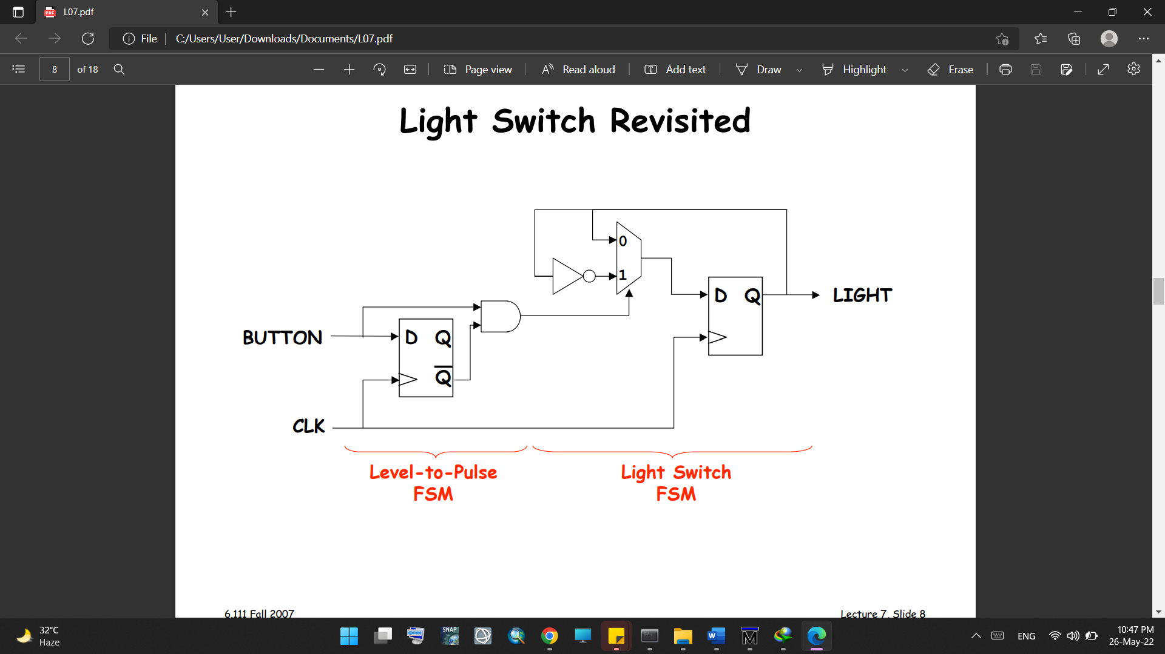

Lab Task:
Code:
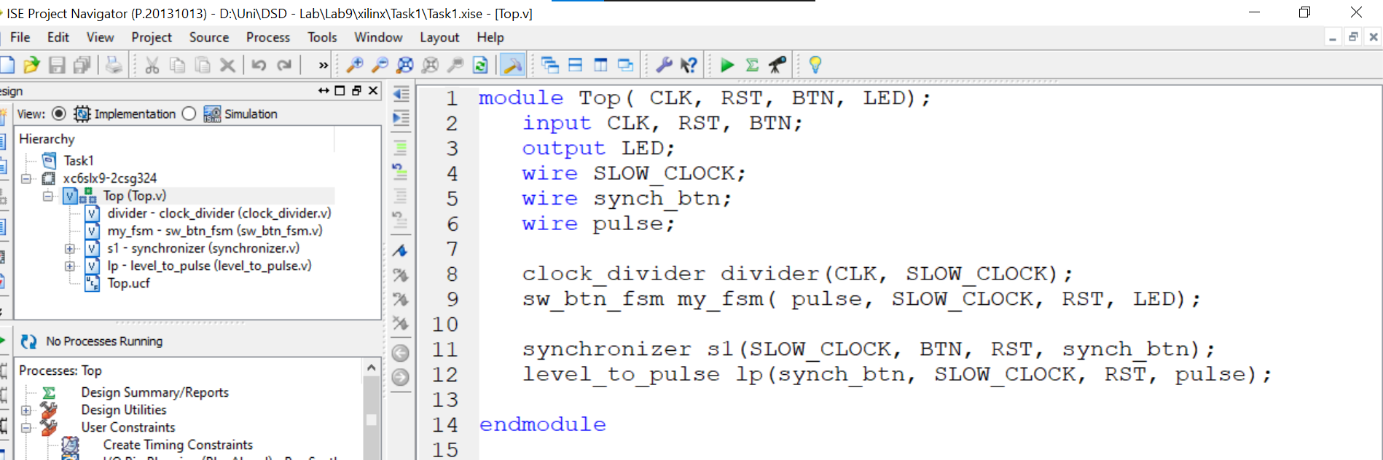
Figure 1.1 top module

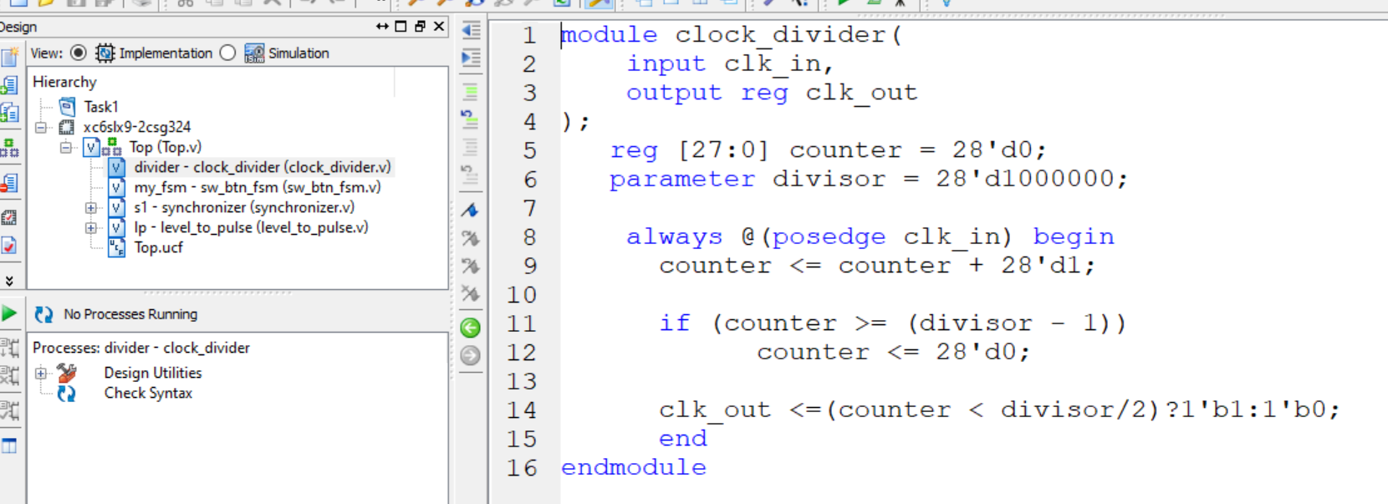
Figure 1.2: Clock DividerCode

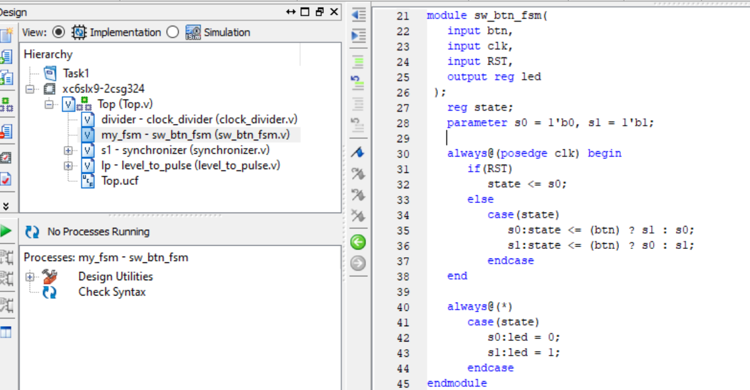
Figure 1.3: Switch Button FSM Code

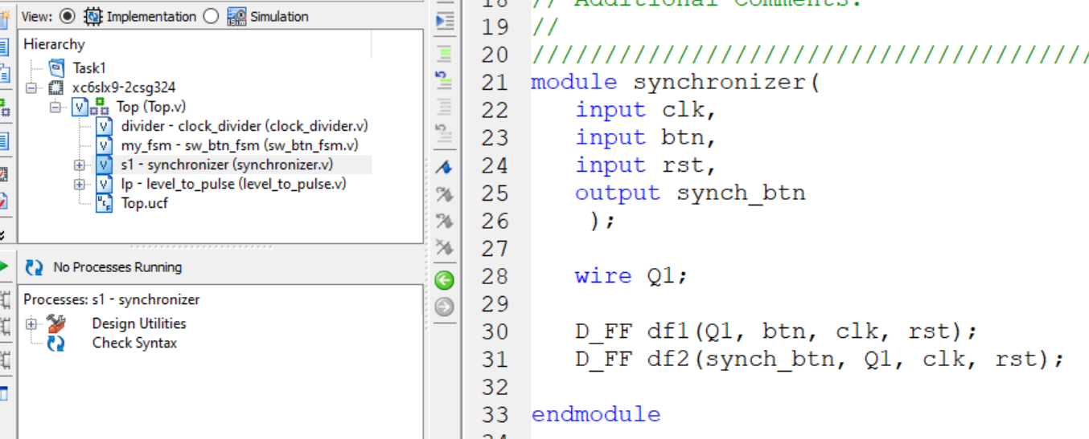
Figure 1.4: Synchronizer Code

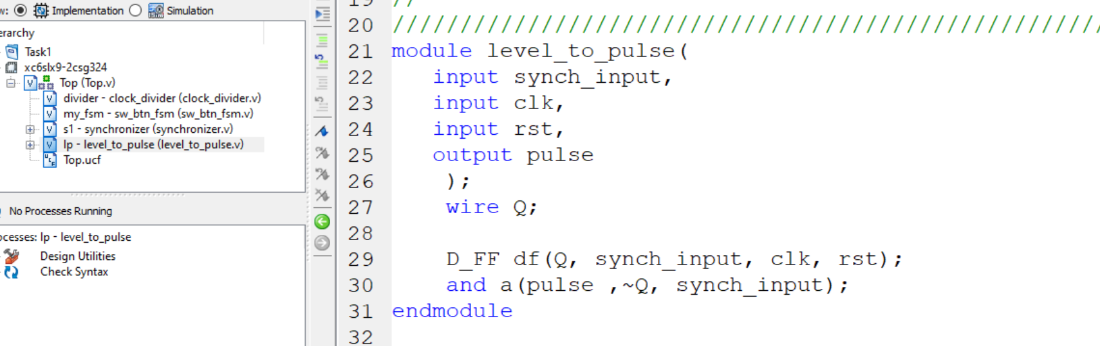
Figure 1.5: Level to Pulse Converter Code

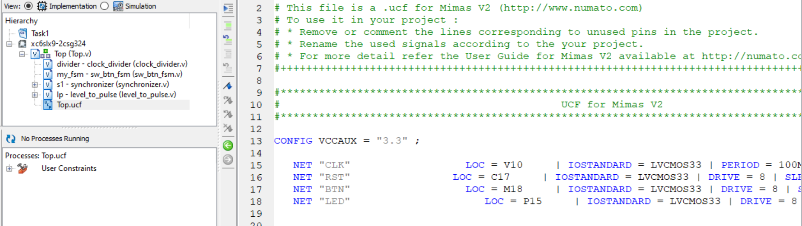
Figure 1.6: UCF File

Output:
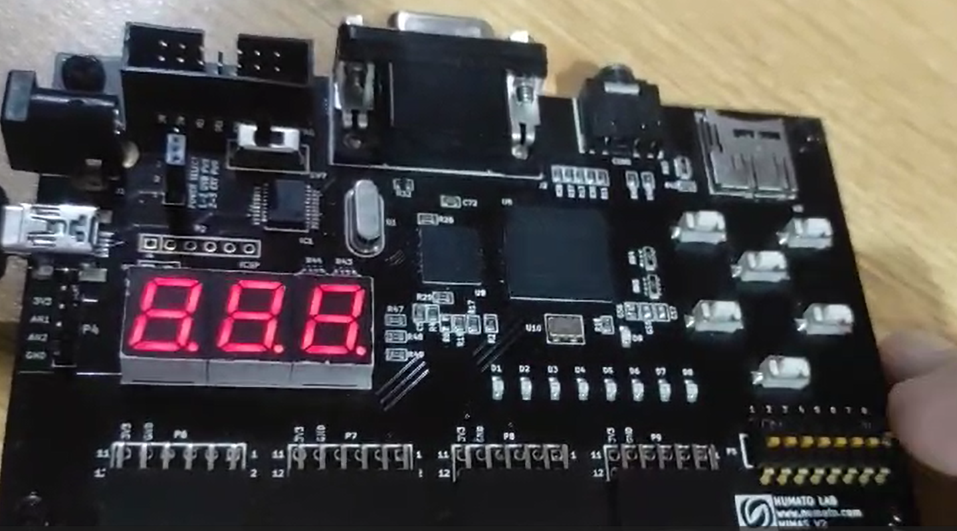
Figure 2.1: Light Switch Implementation on Spartan6 FPGA Board (Off State)

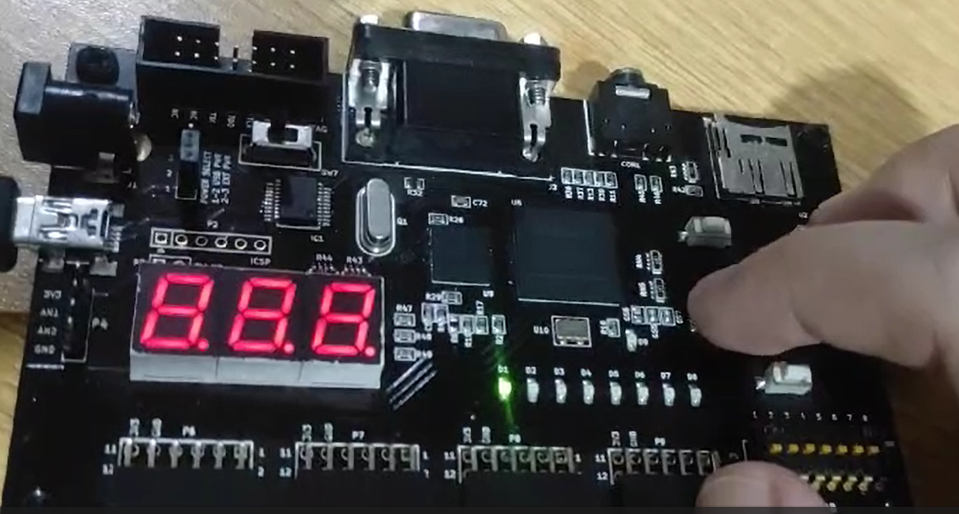
Figure 2.2: Light Switch Implementation on Spartan6 FPGA Board (On State)

